APPLICATION EXECUTION:The program uses **Java 17 so JDK/JRE** must be on that level.

The program can be run after unzipping the code and opening the java directory in a command line using **cd** command:

Linux/macOS *: cd code/src/main/java*

Windows: *cd code\src\main\java*

All the below command must be run inside java directory

Then compiling using **javac** command:

Linux/macOS*: javac tz/co/vodacom/bujikun/Main.java*

Windows: *javac tz\co\vodacom\bujikun\Main.java*

Then execution using **java** command:

Linux/macOS: java tz/co/vodacom/bujikun/Main

Windows: *java tz\co\vodacom\bujikun\Main*

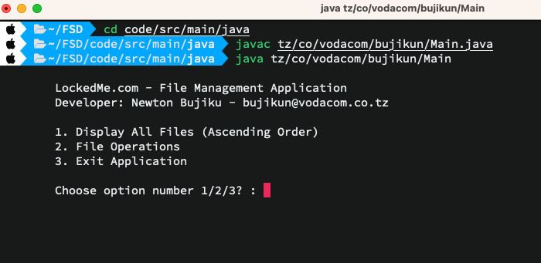

**1.Displaying files**

When the program launches, it will create 2 files in the root directory which can be found from the location where the app was launched from.These can be viewed by choosing 1 from the main menu.

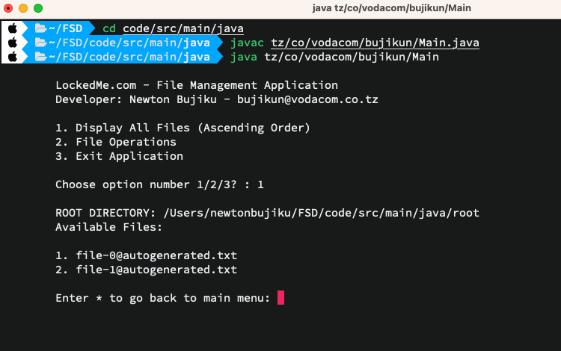

The program will also create additional files if launched with command line options like below

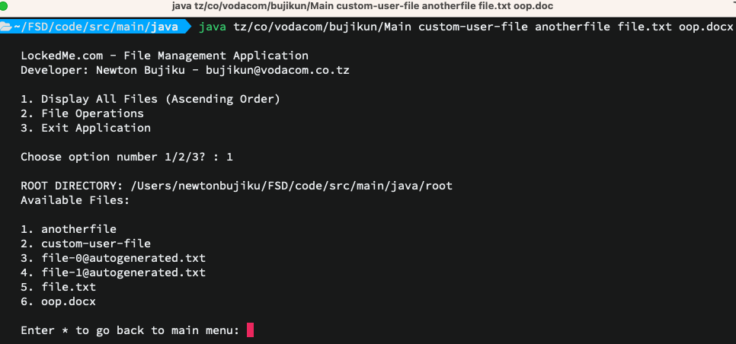

**Navigation**

The application uses * for navigation through various application part. Any attempt to create a file containing * will be ignored. If a file containing * is created manually in the root directory, it will be deleted by a watcher thread.

**2.a Creating a new file**

All user entered valid file names will be created as files in the root directory

When a file is created successfully the application will print a success message and list all file and go back to file operations menu. If the file was not created an error message will be printed.

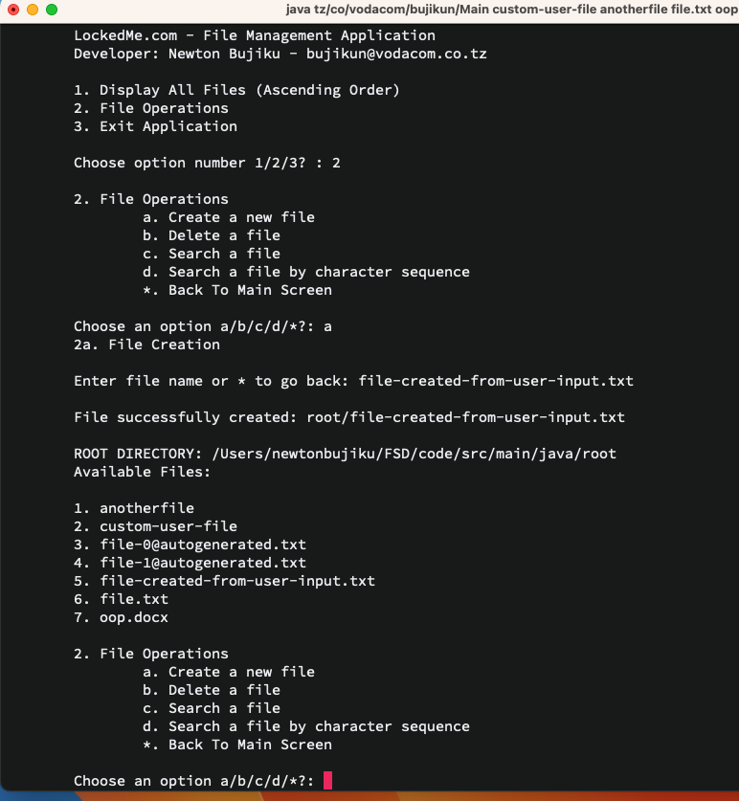

**2.b File deletion**

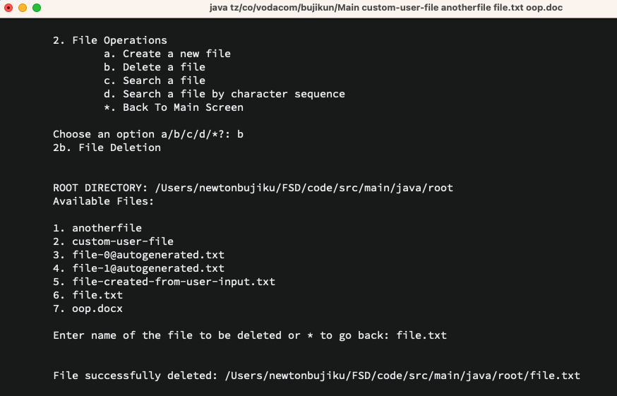

**2.c File Search by exact file name**

A name of the file and extension(if any) must be typed exactly otherwise it will be an error

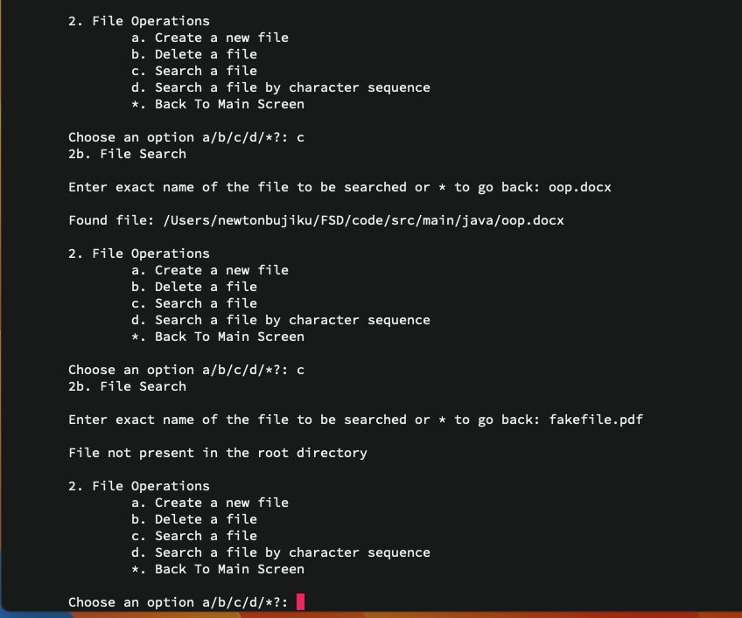

**2.d File search by a sequence of characters**

Provide a search string, and if any of the file names contains that string, the file will be displayed.

